FPC连接器 2.54mm间距
LZ-FPC25.4A-03A
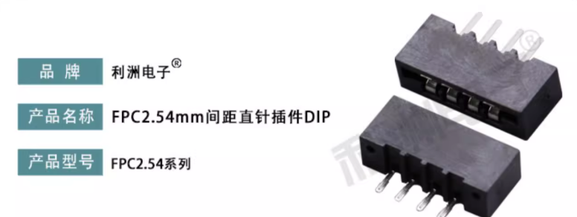

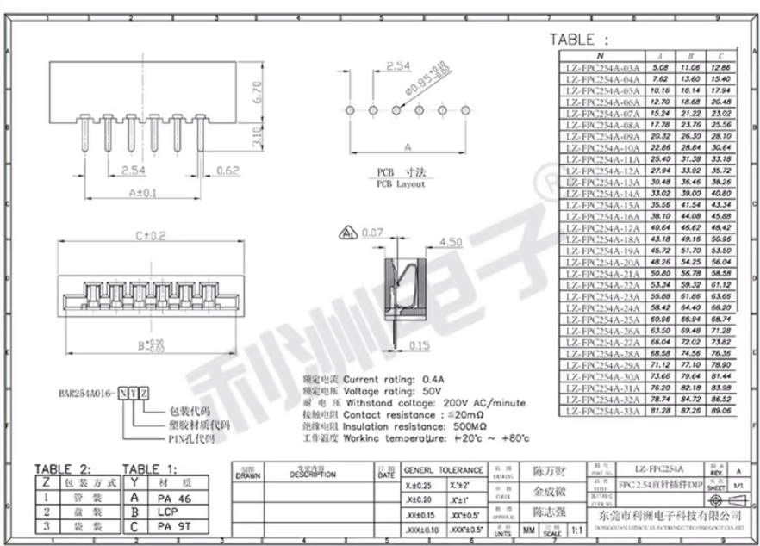

https://nl.mouser.com/ProductDetail/TE-Connectivity-AMP/5-520315-3?qs=lnVw2K6okukuuQdbziEh6w%3D%3D

